|  |  |
| --- | --- |
| logo1.png | CPA stands for “Collaboration Patterns Assistant” and is a software module that supports pattern-based collaborations among dispersed groups (e.g. Virtual Organizations). CPA provides the necessary functionality that allows the recommendation, execution and management of collaboration patterns ([CPats](http://www.imu.ntua.gr/?q=node/269)). |

**Contact Person:** [Nikos Papageorgiou](http://www.imu.ntua.gr/?q=node/3)

**Approach**  
  
The CPA is an application with the aim to support the pattern-based collaboration within a group. The client-side of the CPA is responsible for the communication of the system with the users and the data exchange during the initiation and execution of CPats. The users of the CPA, from the point of view of the system, are distinguished in two general roles: (i) CPat initiators and (ii) CPat participants. CPat initiators are responsible for the initiation and the termination of a new collaboration according to the selected CPat. CPat participants use the CPA in order to get information about the current activities inside their group, to participate in collaborations performed within a planned CPat and to get informed about their assigned tasks. The candidate CPat initiators are determined by the system according to the specification of each CPat. CPats are stored in OWL in the CPat KB.

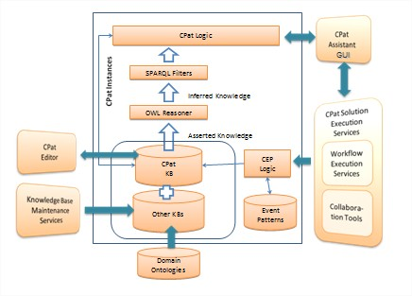

CPA Architecture

The server-side of the CPA implements the CPA business logic. In order to achieve its goals it is required to obtain information from external systems and services. CPat specifications are inserted into the system by the CPat Editor (CPE). The knowledge about the current status of the collaborating group is being retrieved by external knowledge base maintenance services. Information about the events that occur during collaboration arrives to the CPA through the Complex Event Processing subsystem (CEP).   
  
**Publications**

* Y. Verginadis, D. Apostolou, N. Papageorgiou, G. Mentzas. Collaboration Patterns in Event-Driven Environment for Virtual Organisations. Intelligent Event Processing – Association for the Advancement of Artificial Intelligence (AAAI) Spring Symposium 2009, Stanford, USA.
* Y. Verginadis, D. Apostolou, N. Papageorgiou, G. Mentzas. An Architecture for Collaboration Patterns in Agile Event-Driven Environments. Fourth IEEE Workshop on Agile Cooperative Process-Aware Information Systems (ProGility 2009), June 29 - July 1, 2009, Groningen (The Netherlands).
* J.P. Lorré, Y. Verginadis, N. Papageorgiou and N. Salatge. Ad-Hoc Execution of Collaboration Patterns Using Dynamic Orchestration. International Conference on Interoperability for Enterprise Software and Applications (IESA 2010), 14-15 April, 2010 Coventry, UK.

**Downloads***Software*

* Collaboration Patterns Assistant ([CPA](http://147.102.23.45:5080/cppsrv/CPA/CPAdesktop.air))
  + Prerequisite: Install [Adobe AIR](http://get.adobe.com/air/)

*Video*

* [CPA](http://147.102.23.45:5080/cppsrv/DEMO/t2_v10_final_2.mp4) in Virtual Organizations