 | CPA stands for “Collaboration Patterns Assistant” and is a software application that supports pattern-based collaborations within and among dispersed teams. CPA provides the necessary functionality for recommending, executing and managing collaboration patterns (CPats).
Contact Person: Nikos Papageorgiou
Approach
CPA is an application supporting pattern-based collaboration within and among groups. The client-side of CPA enables users to collaborate by initiating and executing CPats. CPA users are distinguished in CPat initiators and CPat participants. CPat initiators are responsible for the initiation and the termination of a new collaboration according to the selected CPat. CPat participants use the CPA in order to get information about the current activities inside their group, to participate in collaborations performed within a planned CPat and to get informed about their assigned tasks. Candidate CPat initiators are determined by the system according to the specification of each CPat. CPats are stored in OWL in the CPat KB.
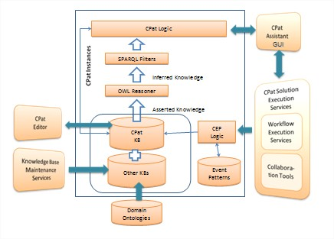
CPA Architecture
The server-side of CPA implements the CPat recommendation, execution and management business logic. CPat specifications are inserted into the system by the CPat Editor (CPE). The knowledge about the current status of the collaborating group is being stored in knowledge bases using the OWL ontology language. Information about the events that occur during collaboration arrives to the CPA through the Complex Event Processing subsystem (CEP).
Publications
- Y. Verginadis, D. Apostolou, N. Papageorgiou, G. Mentzas. Collaboration Patterns in Event-Driven Environment for Virtual Organisations. Intelligent Event Processing – Association for the Advancement of Artificial Intelligence (AAAI) Spring Symposium 2009, Stanford, USA.
- Y. Verginadis, D. Apostolou, N. Papageorgiou, G. Mentzas. An Architecture for Collaboration Patterns in Agile Event-Driven Environments. Fourth IEEE Workshop on Agile Cooperative Process-Aware Information Systems (ProGility 2009), June 29 - July 1, 2009, Groningen (The Netherlands).
- J.P. Lorré, Y. Verginadis, N. Papageorgiou and N. Salatge. Ad-Hoc Execution of Collaboration Patterns Using Dynamic Orchestration. International Conference on Interoperability for Enterprise Software and Applications (IESA 2010), 14-15 April, 2010 Coventry, UK.
Downloads
Software
- Collaboration Patterns Assistant (CPA)
  - Prerequisite: Install Adobe AIR
Video
- CPA in Virtual Organizations

